**VARUN KUMAR**

**2K19-IT-140**

**DS LAB - 2**

**PROGRAM-03**

# Write a program to insert an element at the mid position in the One-dimensional array.

**CODE-**

**#include <stdio.h>**

**int main(){**

**int n; scanf("%d",&n);**

**int a[n+1];**

**for(int i=0;i<n;i++) scanf("%d",&a[i]);**

**printf("enter element: " );**

**int element; scanf("%d",&element);**

**if(n%2==0){**

**int mid=n/2,idx=n;**

**while(idx!=mid){**

**a[idx]=a[idx-1];**

**idx--;**

**}**

**a[mid]=element;**

**}**

**else{**

**int mid=n/2,idx=n;**

**while(idx!=mid){**

**a[idx]=a[idx-1];**

**idx--;**

**}**

**a[mid]=element;**

**}**

**for(int i=0;i<=n;i++) printf("%d ",a[i]);**

**return 0;**

**}**

**INPUT-**

**5**

**1**

**2**

**3**

**4**

**5**

**enter element: 6**

**OUTPUT-**

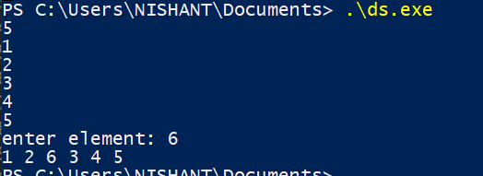

**PROGRAM-04**

Write a program to delete a given row in the two-dimensional array.

**CODE-**

**#include <stdio.h>**

**int main(){**

**int row,col; scanf("%d%d",&row,&col);**

**int mat[row][col];**

**for(int i=0;i<row;i++){**

**for(int j=0;j<col;j++) scanf("%d",&mat[i][j]);**

**}**

**int row_deleted;**

**printf("enter row to be deleted: ");**

**scanf("%d",&row_deleted);**

**for(int i=row_deleted ; i<row-1 ; i++){**

**for(int j=0 ;j<col ; j++){**

**mat[i][j]=mat[i+1][j];**

**}**

**}**

**for(int i=0;i<row-1;i++){**

**for(int j=0;j<col;j++) printf("%d ",mat[i][j]);**

**printf("\n");**

**}**

**return 0;**

**}**

**INPUT-**

**3**

**3**

**1**

**2**

**3**

**4**

**5**

**6**

**7**

**8**

**9**

**enter row to be deleted: 1**

**OUTPUT-**

